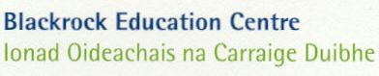
Please attach one class book list to bundle of books and bring a spare copy

Write a Book - Class Book List
If filling this form by hand please use capitals.
Teacher’s name
School Roll No |  |  | School Name
Total of Books  delivered |  |  | Total of children participating |  |  | Class *
AUTHOR’S NAME |  |  |  | BOOK TITLE
1
2
3
4
5
6
7
8
9
10
11
12
13
14
15
16
17
18
19
20
21
22
23
24
25
26
27
28
* If bundle is for two classes then it will be considered as the higher class, i.e. a bundle of 1st & 2nd classes will be registered as a 2nd class
This form can be downloaded and typed from www.writeabookproject.ie

